**Lab Exercise: 6**

**Aim:** Create a sample Maven project using Eclipse and CLI

Create a sample maven project using command line prompt

**Procedure:**

Use the following commands:

1. mvn archetype:generate -DgroupId=com.mycompany.app -DartifactId=my-app -DarchetypeArtifactId=maven-archetype-quickstart -DarchetypeVersion=1.4 -DinteractiveMode=false

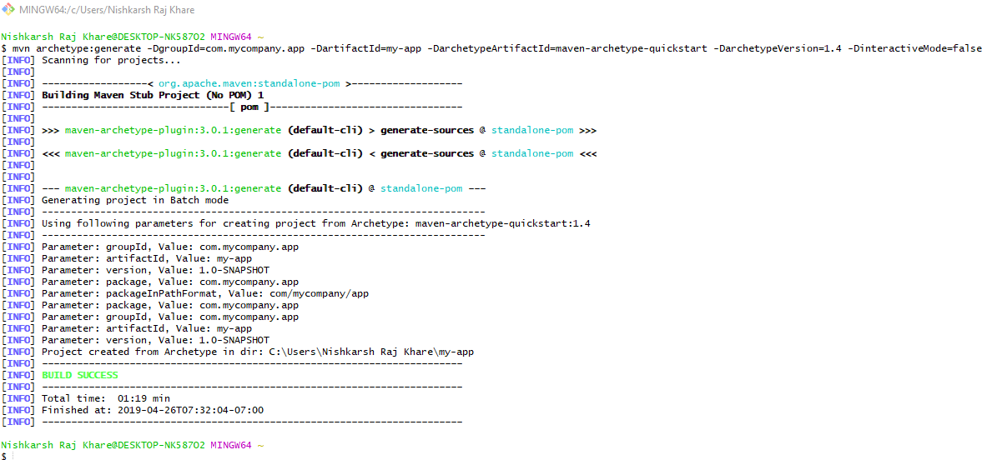

1. Mvn compile

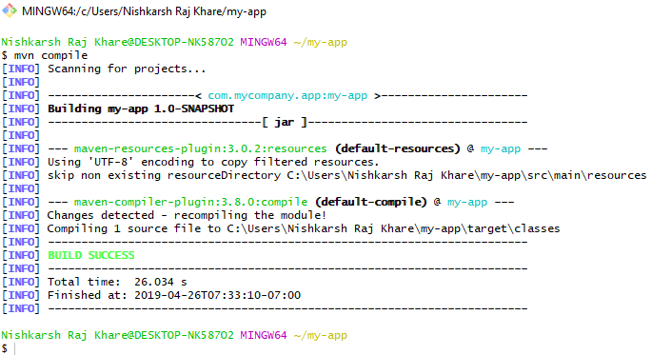

1. Mvn install

